Google Drive File Upload

Objective

The use of this step is to upload a binary file to google drive via REST API by passing required information as a JSON format. We can also upload from AWS S3, One drive to google drive

UI

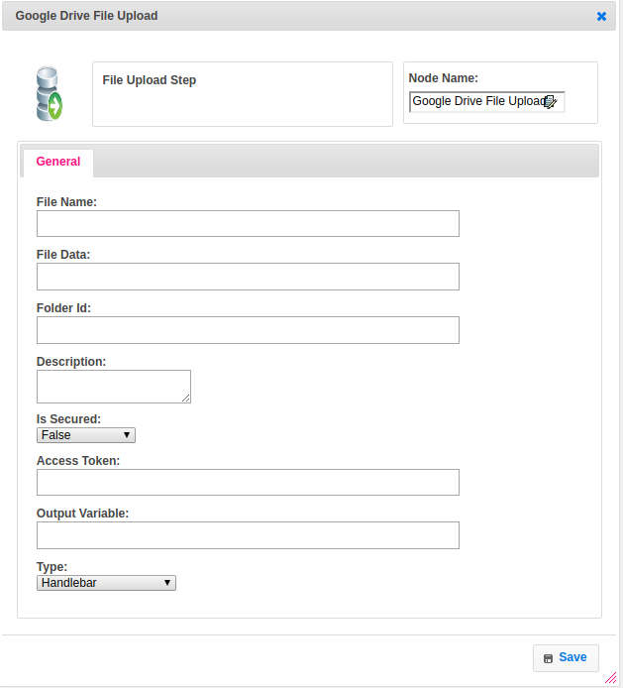

## Attributes

|  |  |  |
| --- | --- | --- |
| **Sl No.** | **Property** | **Explanation** |
| 1. | **file_name** | This property is used to set the name of file |
| 2. | **file_data** | This property accept binary data to upload |
| 3. | **folder_id** | This property is used to upload the file to specific folder id or it’s optional |
| 4. | **description** | This property is about setting the description of file |
| 5. | **file_access** | This property is used to enable or disable the permissions to uploaded file like download and view for shared file i.e. true or false |
| 6. | **access_token** | This property is used to get the access token from google Oauth generated and we are sending that token along with our url as Authorization header.  Ex. Beaer “access_token” |
| 7. | **output_variable** | This property is used to hold the generated URL for accessing or displaying the file to next step |
| 8. | **value_type** | This property type of Handlebars or FTL |
| 9 | **Is Secured** | This property is used to secure the doc file if you specify true then the security apply else not |

## Executor Description

**Step by step process……………………..follows**

* Created a url for hitting.
* Created RequestBody variable for metadata
* And created if condition for folder id is empty then pass the metadata without folder id else passing metadata with folder id
* Decoded the received file data byte[] fileBytes = Base64.*decodeBase64*(step.getFile_data());
* And created FormDataPart Builder for adding metadata along with file content
* And made a post call with bearer token
* And executed that request using OkHttpClient Ex. Response response = okHttpClient.newCall(request).execute();

## Resource

More information about Google Drive API file download please refer the following link.

https://developers.google.com/drive/api/v3/multipart-upload